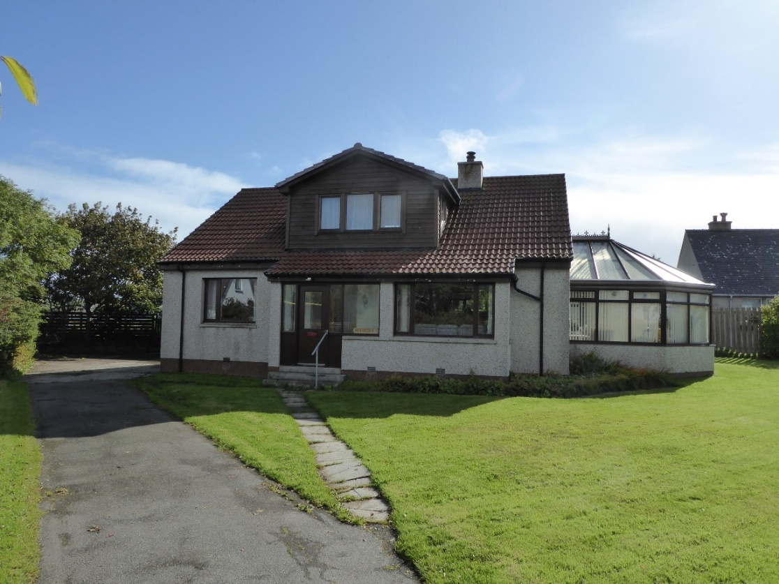

1 KANTERSTED ROAD, LERWICK

This spacious 2 storey, 3 bedroom detached house with a large conservatory and detached double garage is situated in an enclosed mature garden to front and rear. It is ideally placed for access to the town centre and all amenities, including the Clickimin Leisure Centre, Anderson High School and Tesco supermarket. Perfect for a family home, viewing is highly recommended. Some of the furniture is included in the sale.

EPC RATING D (56)

ENTRY Immediate by arrangement

PRICE Offers over £285,000

VIEWING Contact our Reception

ACCOMMODATION Entrance Hall, Living Room, Kitchen, Dining Room, Bathroom, Three Bedrooms (one with en-suite Shower Room), Sitting Room/ Office, Conservatory and detached double Garage
1 KANTERSTED ROAD, LERWICK

The property was built c. 1964 as a detached single storey residence and is situated in a plot extending to 0.1 ha approx. The roof space was developed into accommodation c. 2001 and provides a large open plan double bedroom with an en-suite shower room and separate sitting room/office. The house is double-glazed throughout and heating is provided by an external oil-fired Warmflow boiler.

Accommodation comprises:

Ground Floor

PORCH - (Approx. 2.8m x 0.95m)
The porch is accessed by the half-glazed timber front door and has windows to the front and sides. The walls are V-lined with a cream painted finish while the sills have a natural wood finish. Coach lamps are fixed to either side of the natural pine glazed inner door.

HALLWAY
The T shaped Hallway features wood laminate flooring, brass wall-mounted picture lights and a single radiator. Glazed doors lead to the Living Room, Dining Room and Kitchen. Other doors open to a Bathroom and to the two ground floor Bedrooms. There is a cupboard housing the hot water cylinder and a further understair storage cupboard with natural timber finish louvre door. The natural pine chest of drawers is included in the sale.

LIVING ROOM - (Approx. 4.9m x 3.4m)
The Living room features a large bay window overlooking the front garden (approx. 2.4m wide x 1.0m deep), wood laminate flooring, a fireplace with tiled hearth and surround and natural pine mantlepiece with solid fuel stove, stainless steel and glass central light fitting and two wall lamps, smoke alarm, one double radiator and two double sockets. Double french doors lead out to the Conservatory. The matching three-seater sofa, two-seater sofa and armchair are included in the sale as are the natural timber coffee table, combined drawer and glass fronted cabinet and TV base unit.

BATHROOM - (Approx. 3.0m x 1.8m)
The Bathroom has wood laminate flooring and is tiled in white up to dado height. The white bathroom suite comprises a toilet, washbasin and bath with a shower mixer tap, Wetwall lining and folding glass shower screen. With towel warmer and mirror over the basin.

KITCHEN - (Approx. 4.2m x 2.75m)
The Kitchen features tile effect flooring and has substantial wall and floor mounted units with worksurfaces above, tiled splashbacks and four electric double sockets at worksurface level. Appliances include an integral Hotpoint double oven, inset Tricity four burner ceramic hob with extractor fan above, Bloomberg washing machine and Bosch dishwasher. There are two additional full height storage cabinets, one with integral fridge and freezer. Other features include a double panel radiator and 1½ drainer stainless steel sink. The window with roller blind overlooks the back garden and a glazed single door leads to the Conservatory.

CONSERVATORY - (Approx. 5.0m x 4.0m max)
The spacious south-west facing double-glazed Conservatory provides a bright sheltered warm area for use as a sun-room and/or for growing plants. A glazed door leads out to the back garden. The windows are fitted vertical strip blinds. Other features include a central combined fan and light unit, tiled floor and two double sockets.

DINING ROOM - (Approx. 3.3m x 3.0m)
The carpeted Dining Room contains an extending dining table, 6 chairs and dresser, all in pine and all included in the sale. The window has a south-easterly aspect and overlooks the rear garden/patio. With single panel radiator, central pendant light fitting and one double and one single electrical socket.

BEDROOM 1 - (Approx. 4.0m x 2.8m)
This carpeted double bedroom has dual aspect north-east and south-east facing windows, both with curtains, a large double wardrobe with sliding mirror doors, shelving racks and hanging rail, a double panel radiator, one double socket. The 2 natural timber bedside cabinets are included in the sale.

BEDROOM 2 - (Approx. 3.4m x 3.1m)
Also carpeted, this Bedroom has 2 single beds, extensive fitted wardrobes with mirrored doors, hanging rails and shelving and matching 5 drawer chest of drawers. The curtained window with double panel radiator beneath overlooks the front drive.

First Floor

MASTER BEDROOM (Approx. 6.5m x 6.0m max)
The carpeted staircase with pine handrails leads from the Hallway up to a large open-plan carpeted Double Bedroom with windows offering views to the north-west towards the southern tip of Clickimin Loch, and Velux roof lights with integral blinds to the south-east. The large double bed with timber headboard, brass wall-mounted lights, are all included in the sale. Other features include recessed spotlighting, smoke alarm, double panel radiator and 5 double sockets. Access to an under-eave storage area with louvre door. A natural timber door leads into a walk-in storage area with two hanging rails and recessed spotlight.

ENSUITE SHOWER ROOM - (Approx. 3.3m x 2.0m)
With quadrant shower cabinet with double sliding doors and Triton electric shower and extractor fan, toilet and washbasin set into a storage unit with cupboard space and shelving. Other features include a mirror above the basin, shaving socket, wood laminate flooring, single panel radiator and towel rail. A louvre door gives access to further under eave-storage.

SITTING ROOM/OFFICE - (Approx. 3.5m x 4.0m)
Features include a Velux window with integral blind, 2 ceiling lights with dimmer switch, a small cabinet with 3 drawers, a large storage unit with 6 louvre doors and white counter above, 2 double sockets and a single panel radiator.

DOUBLE GARAGE - (Approx. 7.0m x 7.0m)
The detached Garage has 2 roller doors and a separate access door at the front. A second side door opens into the yard at the back but is not usable at the moment. There are 2 workbenches, 2 double sockets and shelving for tools.

GARDEN
The sheltered garden is bordered by a stone wall along Kantersted Road and lined with mature hedges and shrubs, with lawns to the front, side and rear and trees to the side and rear. There is also a paved patio to the rear of the house and an outside tap at the front.

